

**FOUNDATION IN ARTS**

**ASSIGNMENT 1 COVER SHEET**

**SUBJECT TITLE : INTRODUCTION TO PROGRAMMING**

**SUBJECT CODE : PCSC002**

**COURSEWORK TITLE : INDIVIDUAL WORK**

**COURSEWORK** **:** **15%**

**DUE DATE : 25TH FEBRUARY 2024**

The objectives of this assignment are:

* To encourage students to think critically about problem solving in programming.
* To apply the knowledge of Java programming.
* To practice good programming techniques.

The learning outcomes of this assignment is:

* To be able to create basic Java applications.
* To be able to use decision making constructs for problem solving.

Student Name : _____On Yong Jie________________________

Student ID : _____23040959__________________________

Group : ________2______________________________

Task:

1. Write a program to check if a student is allowed to sit for his/her exam or not. It is noted that students can only sit for their exam if their attendance is 75% or above ad their assignment score is 50% or above. Your program should take the following input from user:

* Total number of classes.
* Number of classes attended.
* Score for Assignment 1, Assignment 2 and Assignment 3.
* Total score of all assignments.

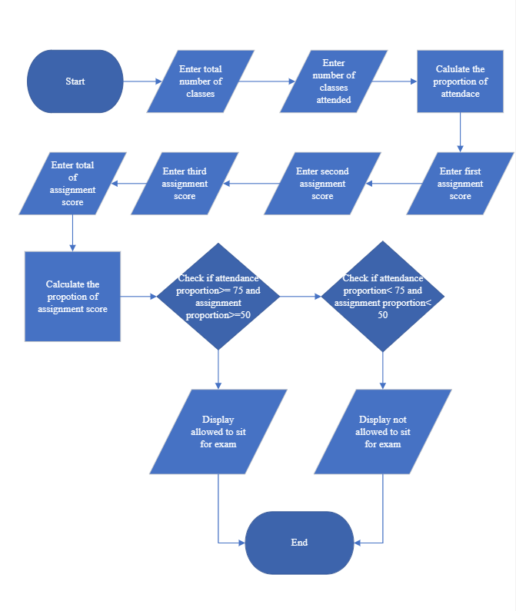

**import** java.util.Scanner;

**public** **class** ExamCheck {

**public** **static** **void** main(String[] args) {

**double** num1; //total number of classes

**double** num2; //number of classes attend

**double** num3; //proportion of attend

**double** asg1; //assignment 1 score

**double** asg2; //assignment 2 score

**double** asg3; //assignment 3 score

**double** asg; //total assignment score

**double** asg4; //proportion of assignment score

Scanner keyboard = **new** Scanner(System.***in***);

System.***out***.println("Enter number of total classes>>");

num1 = keyboard.nextDouble();

System.***out***.println("Enter number of classes attended");

num2 = keyboard.nextDouble();

num3 = num2/num1*100;

System.***out***.println("Enter first assignment score>>");

asg1 = keyboard.nextDouble();

System.***out***.println("Enter second assignment score>>");

asg2 = keyboard.nextDouble();

System.***out***.println("Enter third assignment score>>");

asg3 = keyboard.nextDouble();

System.***out***.println("Enter total assignment score>>");

asg = keyboard.nextDouble();

asg4 = (asg1+asg2+asg3)/asg*100;

**if** ((num3 >= 75)&&(asg4 >= 50)) {

System.***out***.println("Allowed to sit for exam");

}

**else** {

System.***out***.println("Do not allowed to sit for exam");

}

keyboard.close();

}

}

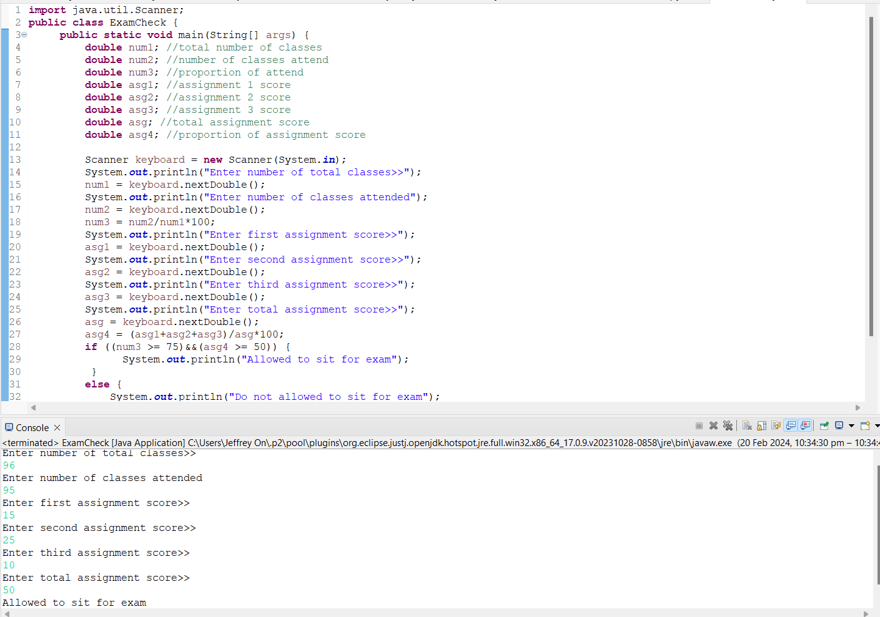Allowed

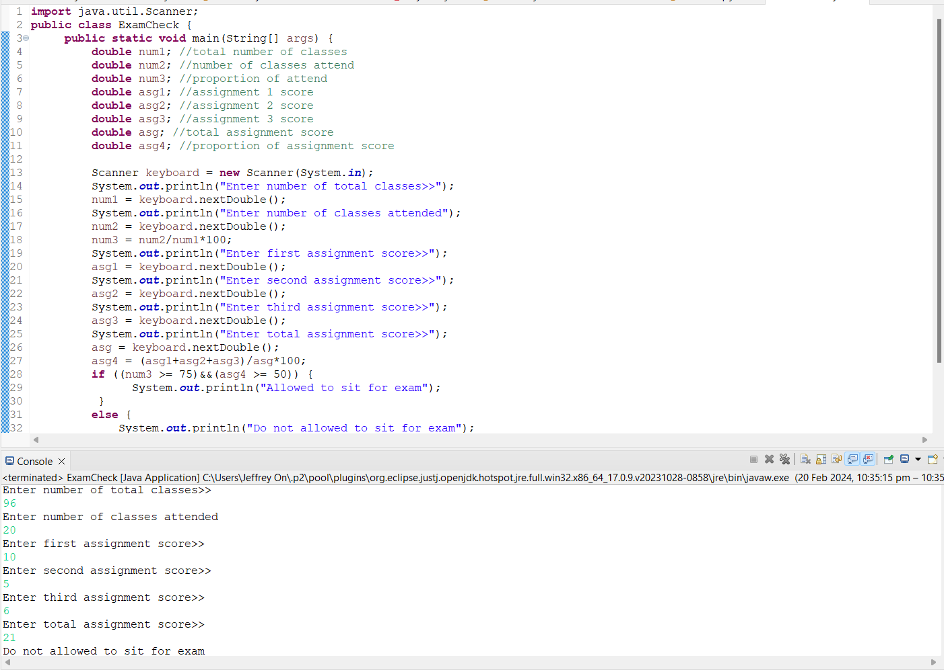Do not allowed

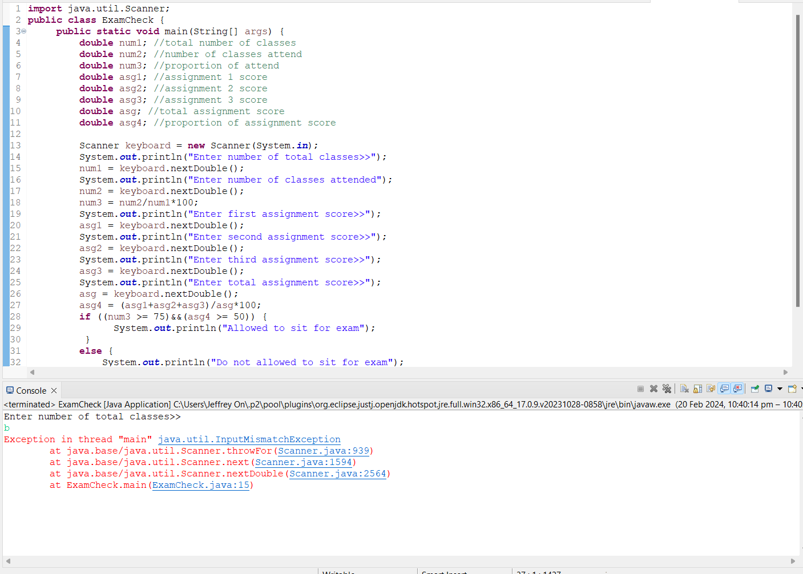Default

Task:

1. Develop a Java program for a car rental system. The program should allow user to choose the type of cars “Compact”, “Sedan”, or ‘SUV” and rental duration “daily”, “weekly”, “monthly”. The base rental rate is $30.50 for Compact car, $50.00 for a Sedan car, and $80.96 for a SUV car. If user choose to go for weekly rentals, there will be a 15% discount rate and if user choose to go for monthly rentals, there will be a 30% discount rate. Higher marks will be given for program created using JOptionPane.

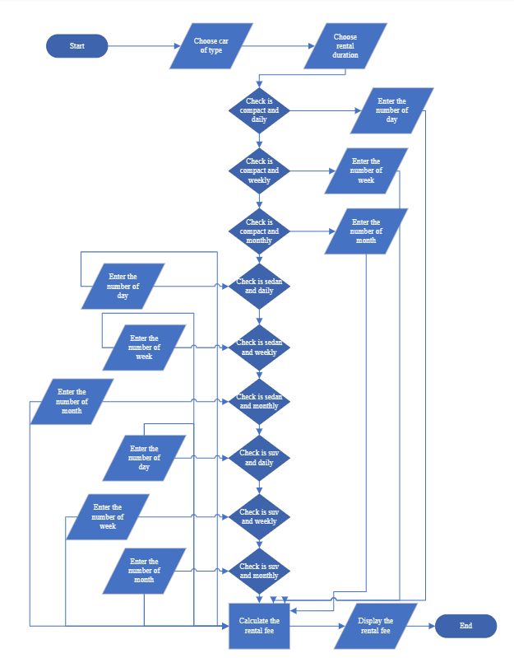

**import** javax.swing.JOptionPane;

**public** **class** CarRent {

**public** **static** **void** main(String[] args) {

String[]carTypes = {"Compact", "Sedan", "SUV"};

**int** car = JOptionPane.*showOptionDialog*(

**null**, "Select type of car", //dialog question

"Car Rental System",

JOptionPane.***YES_NO_OPTION***,

JOptionPane.***QUESTION_MESSAGE***,

**null**,

carTypes,

carTypes[0]);

//the duration choice

String[] duration = {"Daily", "Weekly", "Monthly"};//selection apply

**int** time = JOptionPane.*showOptionDialog*(

**null**,

"Select Rental Duration",//Dialog question

"Duration of Rental",

JOptionPane.***YES_NO_OPTION***,//use the click option

JOptionPane.***QUESTION_MESSAGE***,//icon of the question

**null**,

duration,//the box in the dialog

duration[0]);//the arrangement of selection

**double** compact = 30.50;

**double** sedan = 50.00;

**double** suv = 80.96;

**double** rental;

**int** times;

String timer;

**int** week = 7;

**int** month = 30;

**if** ((car == 0)&&(time == 0)) {

timer =JOptionPane.*showInputDialog*(

**null**,

"Enter number of day rental",

"Day of Rental",

JOptionPane.***QUESTION_MESSAGE***);

times =Integer.*parseInt*(timer);

rental = compact*times;

}

**else** **if** ((car == 0)&&(time == 1)) {

timer =JOptionPane.*showInputDialog*(

**null**,

"Enter number of week rental",

"Week of Rental",

JOptionPane.***QUESTION_MESSAGE***);

times =Integer.*parseInt*(timer);

rental = compact*times*week*0.85;

}

**else** **if** ((car == 0)&&(time == 2)) {

timer =JOptionPane.*showInputDialog*(

**null**,

"Enter number of month rental",

"Month of Rental",

JOptionPane.***QUESTION_MESSAGE***);

times =Integer.*parseInt*(timer);

rental = compact*times*month*0.7;

}

**else** **if** ((car == 1)&&(time == 0)) {

timer =JOptionPane.*showInputDialog*(

**null**,

"Enter number of day rental",

"Day of Rental",

JOptionPane.***QUESTION_MESSAGE***);

times =Integer.*parseInt*(timer);

rental = sedan*times;

}

**else** **if** ((car == 1)&&(time == 1)) {

timer =JOptionPane.*showInputDialog*(

**null**,

"Enter number of week rental",

"Week of Rental",

JOptionPane.***QUESTION_MESSAGE***);

times =Integer.*parseInt*(timer);

rental = sedan*times*week*0.85;

}

**else** **if** ((car == 1)&&(time == 2)) {

timer =JOptionPane.*showInputDialog*(

**null**,

"Enter number of month rental",

"Month of Rental",

JOptionPane.***QUESTION_MESSAGE***);

times =Integer.*parseInt*(timer);

rental = sedan*times*month*0.7;

}

**else** **if** ((car == 2)&&(time == 0)) {

timer =JOptionPane.*showInputDialog*(

**null**,

"Enter number of day rental",

"Day of Rental",

JOptionPane.***QUESTION_MESSAGE***);

times =Integer.*parseInt*(timer);

rental = suv*times;

}

**else** **if** ((car == 2)&&(time == 1)) {

timer =JOptionPane.*showInputDialog*(

**null**,

"Enter number of week rental",

"Week of Rental",

JOptionPane.***QUESTION_MESSAGE***);

times =Integer.*parseInt*(timer);

rental = suv*times*week*0.85;

}

**else** {

timer =JOptionPane.*showInputDialog*(

**null**,

"Enter number of month rental",

"Month of Rental",

JOptionPane.***QUESTION_MESSAGE***);

times =Integer.*parseInt*(timer);

rental = suv*times*month*0.7;

}

JOptionPane.*showMessageDialog*(

**null**,

"The rental fee is $"+rental,

"Rental Fees",

JOptionPane.***INFORMATION_MESSAGE***);

}

}

Compact Daily

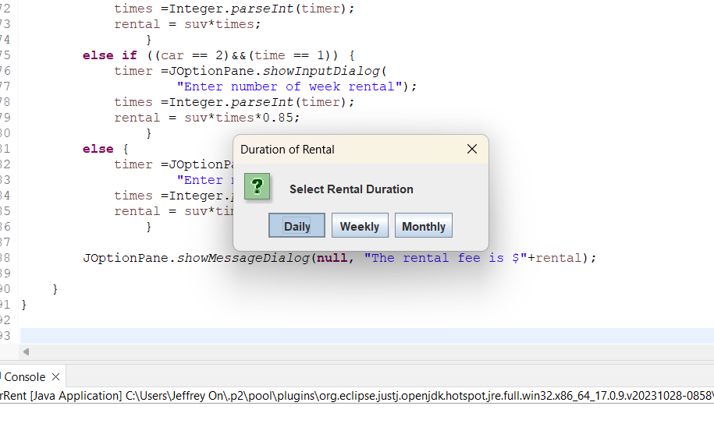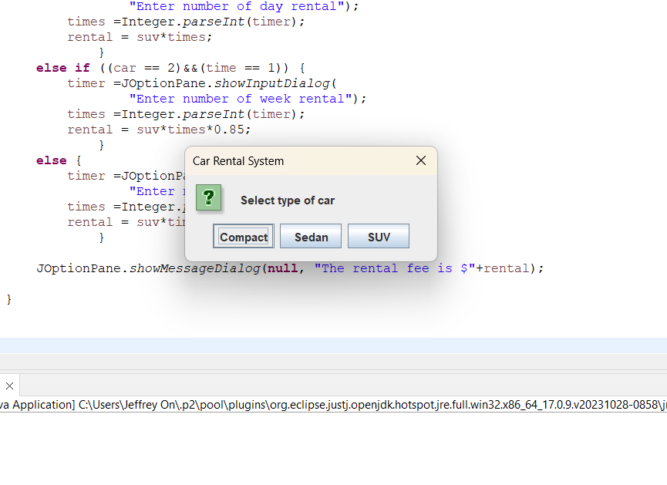 (Positive Number)



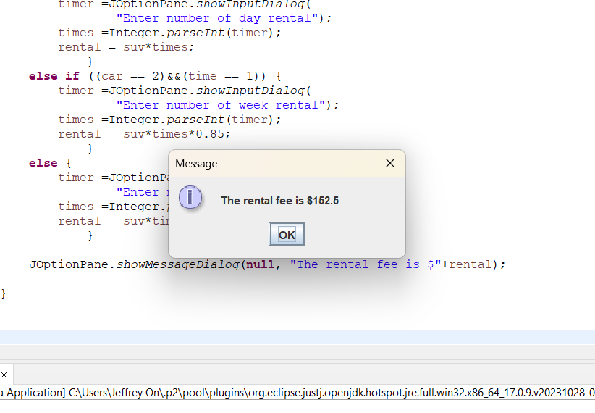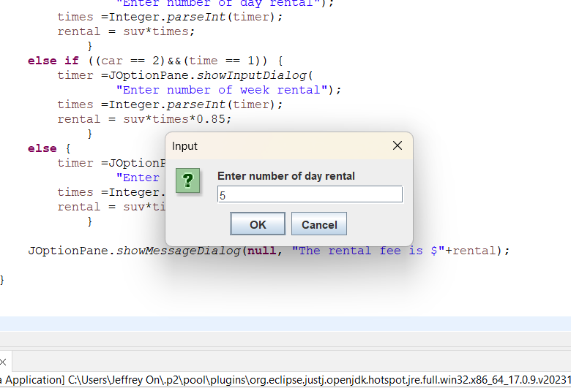

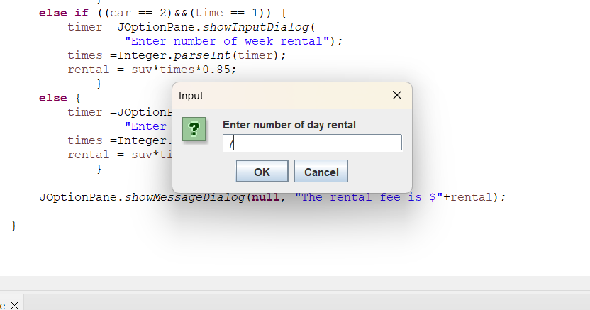(Negative Number)

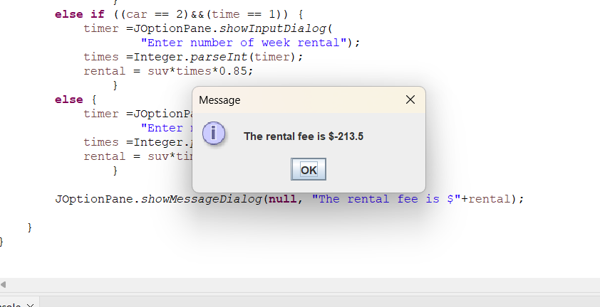

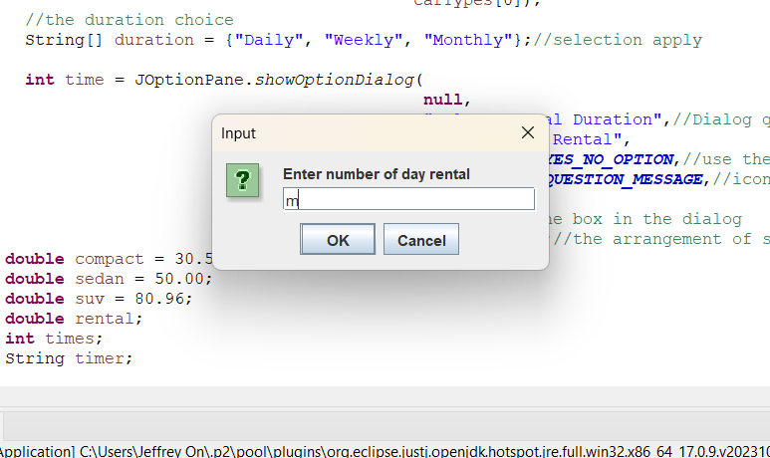(Default)

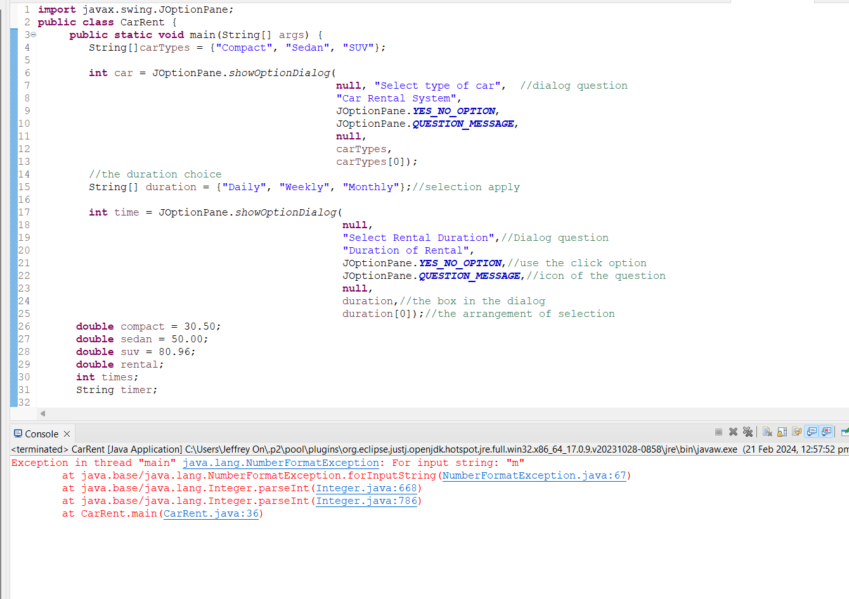

Compact Weekly

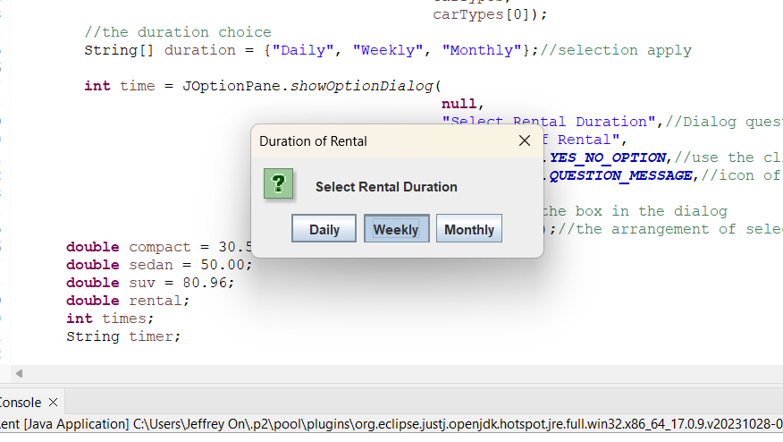(Positive Number)

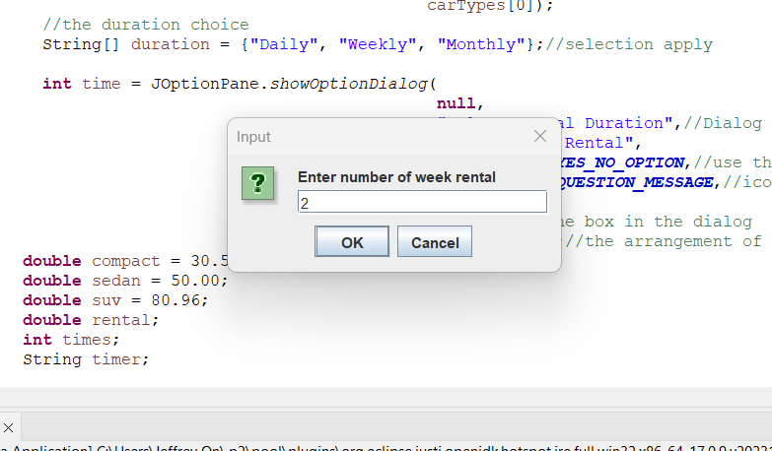

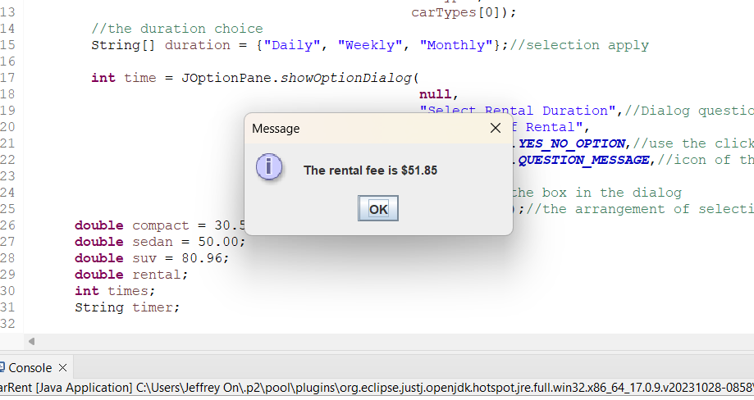

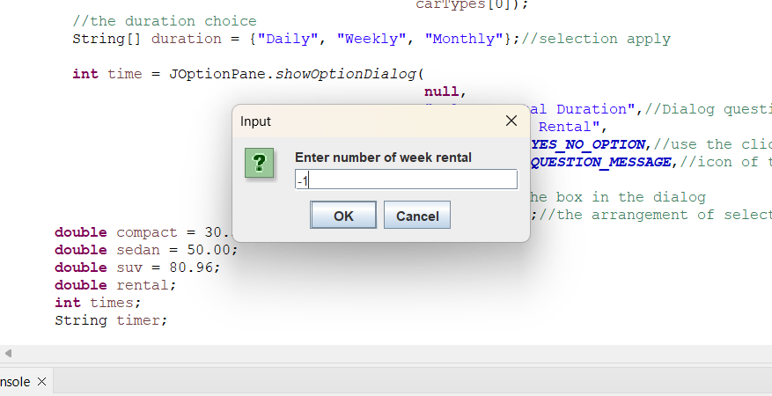(Negative Number)

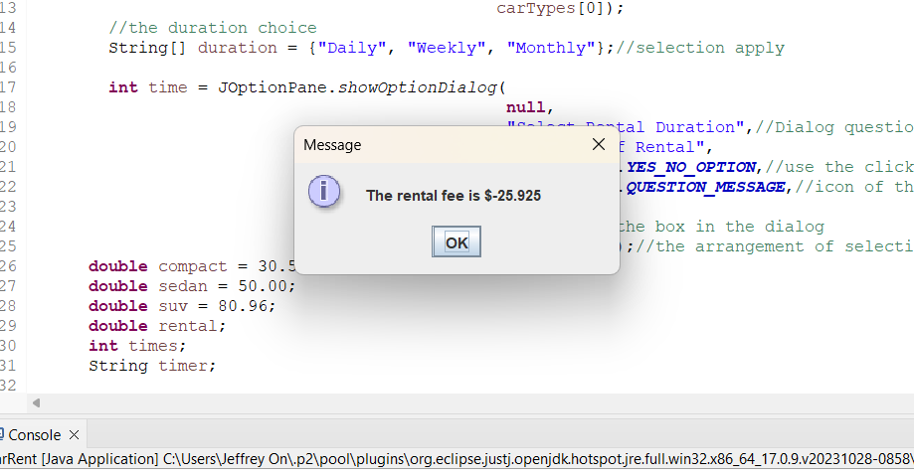

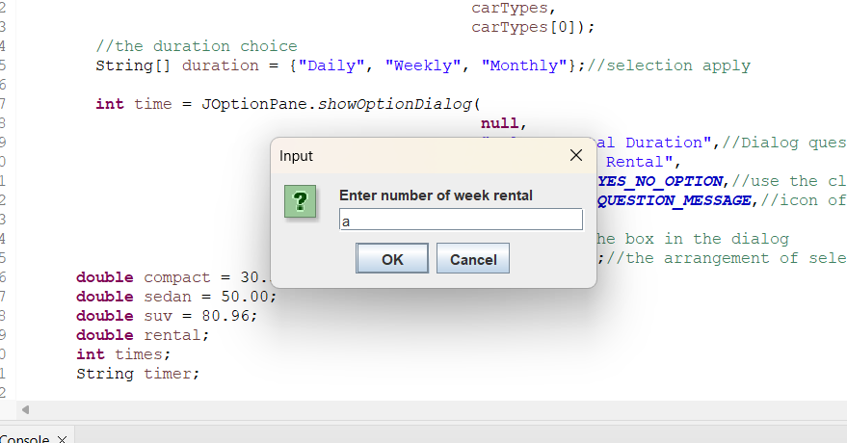(Default)

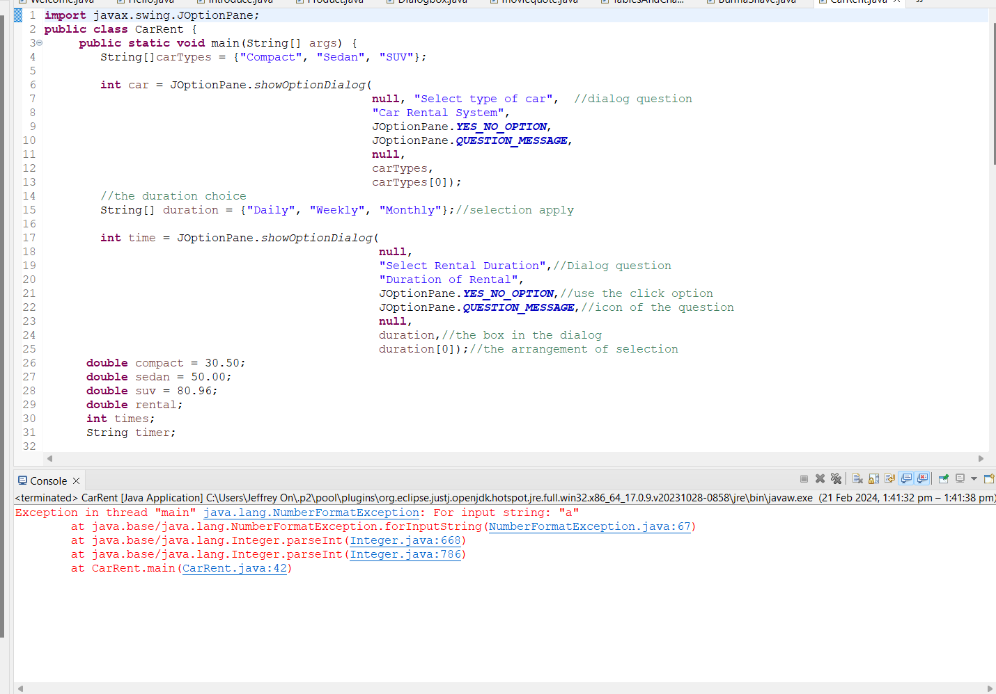

Compact Monthly

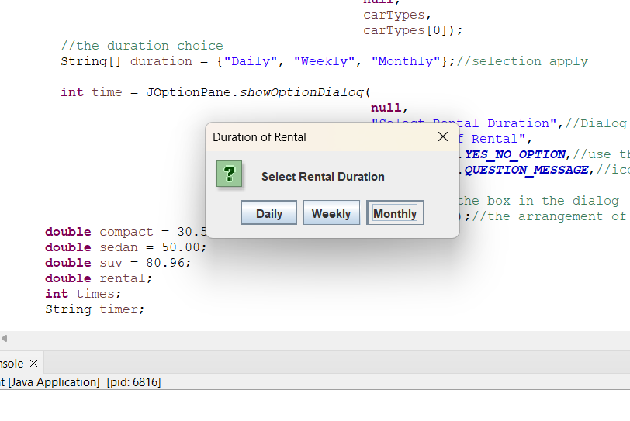(Positive Number)

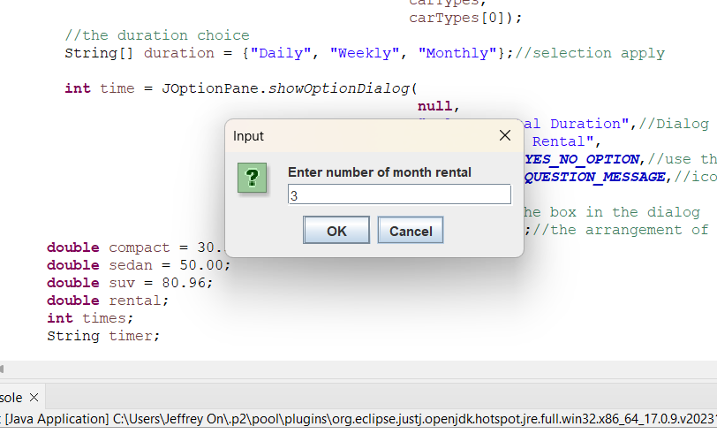

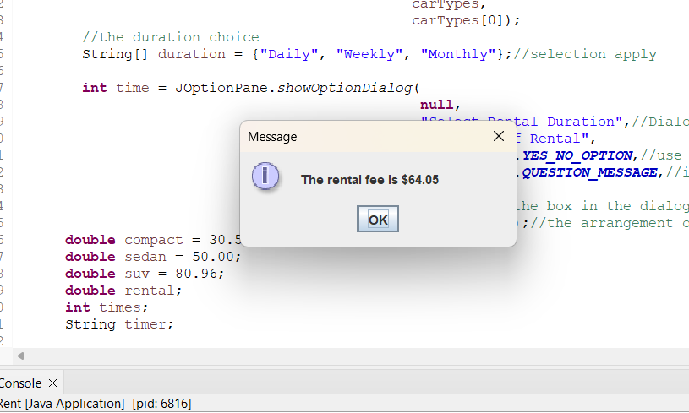

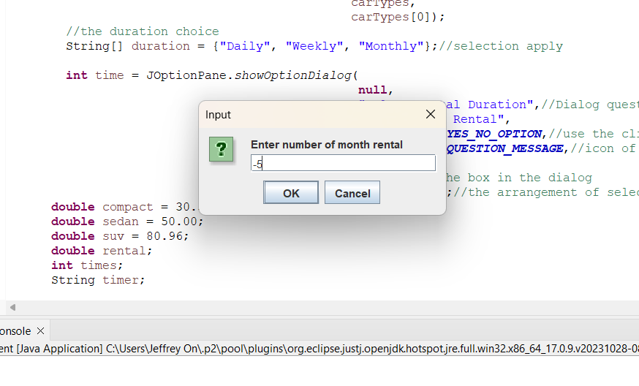(Negative Number)

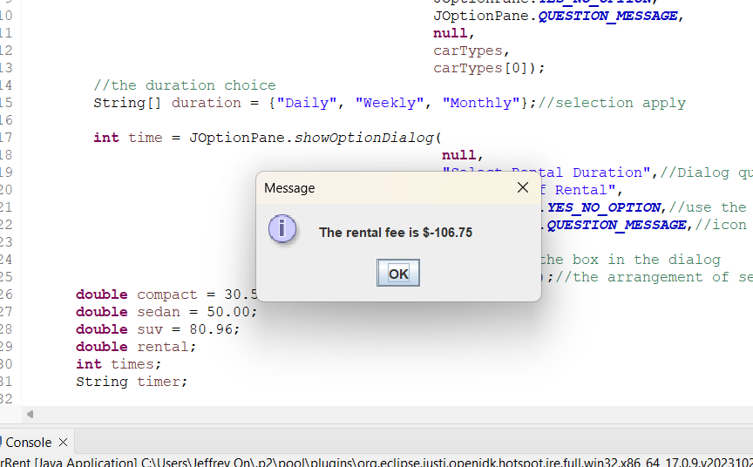

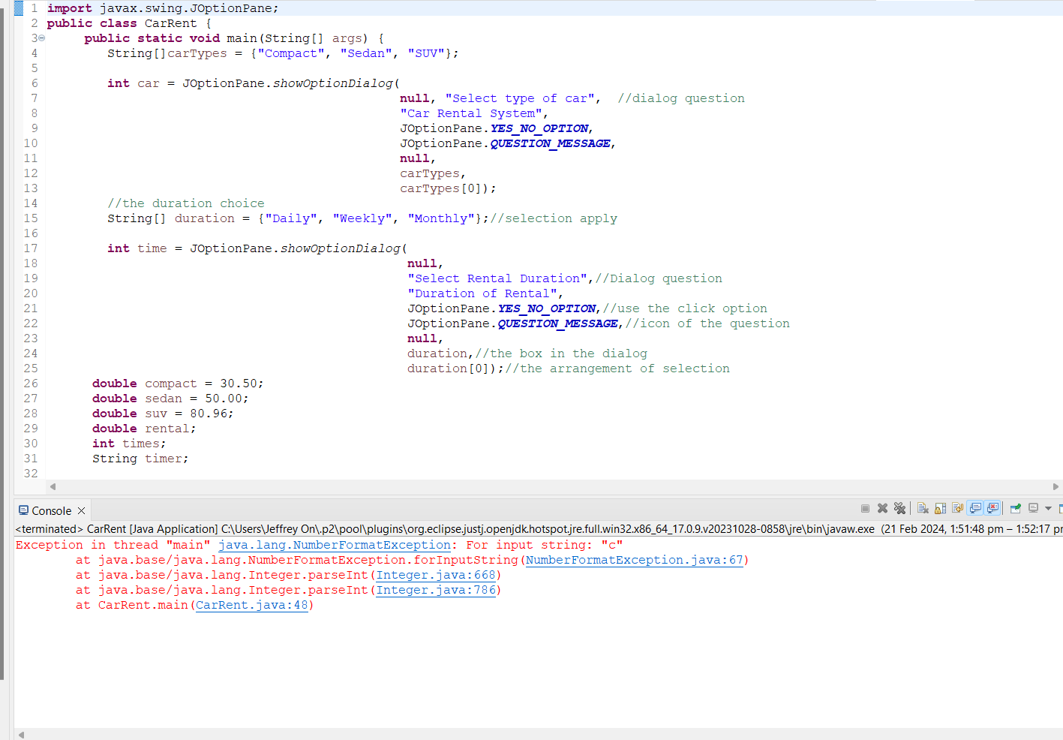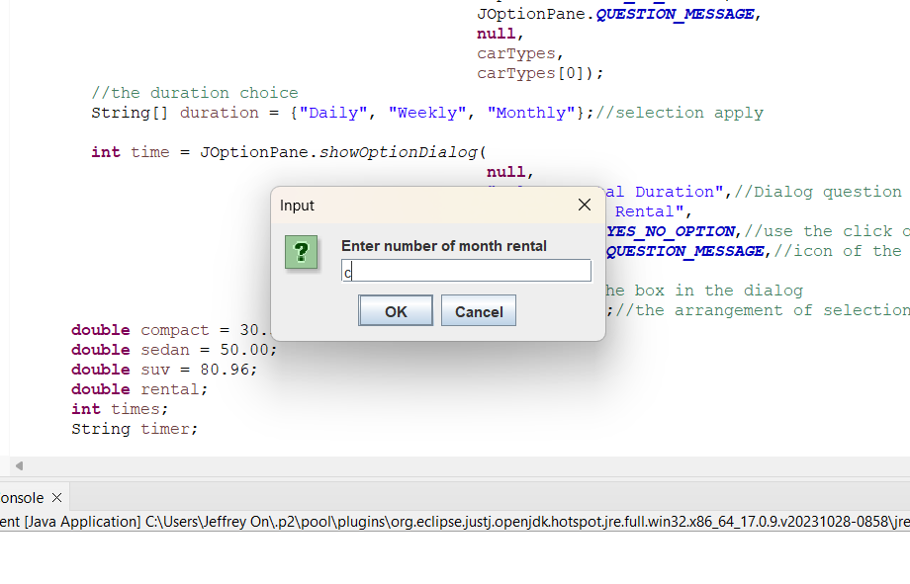(Default)

Sedan Daily

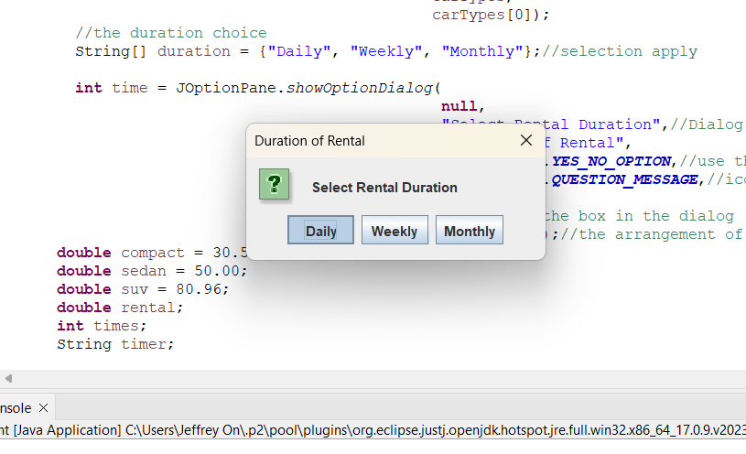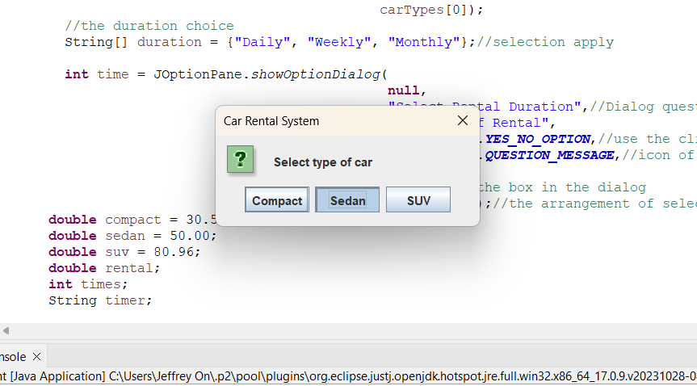(Positive Number)

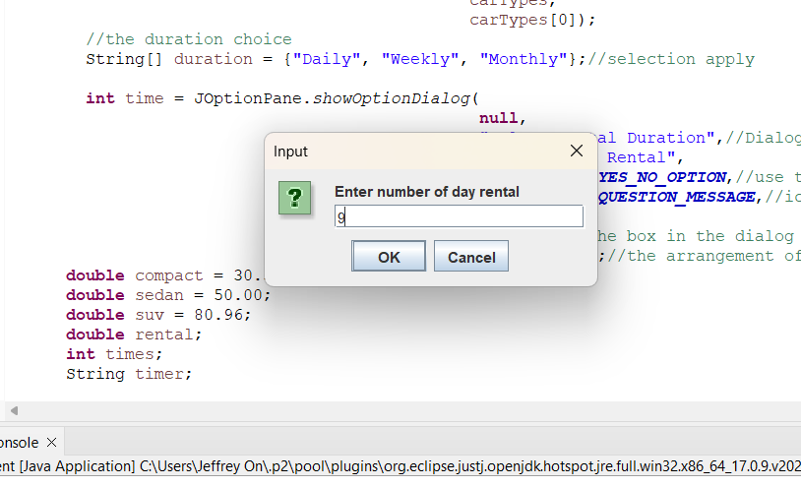

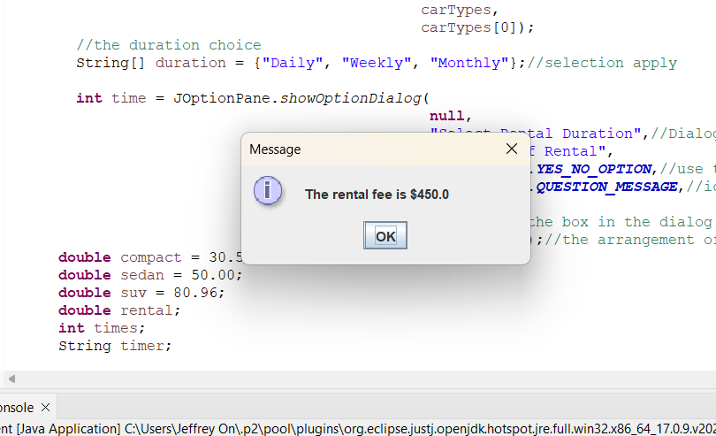

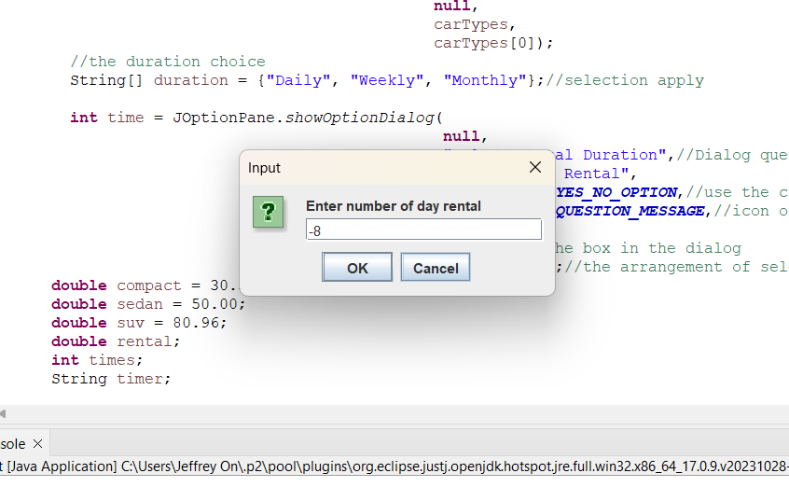(Negative Number)

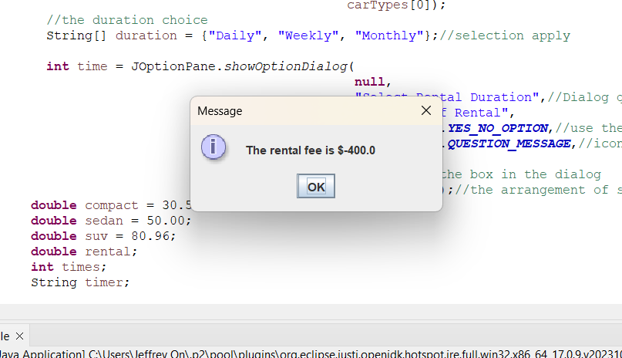

(Default)

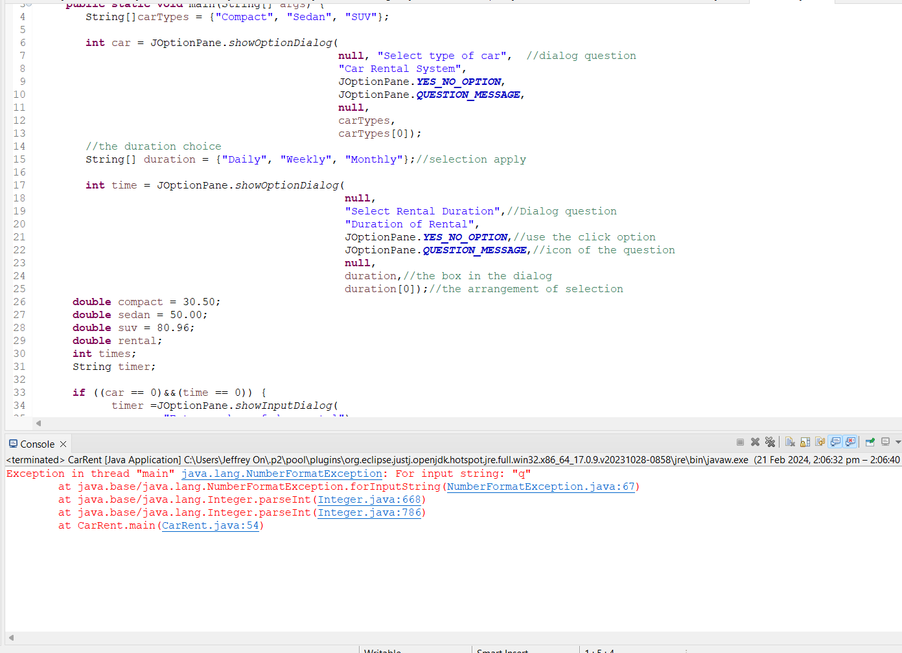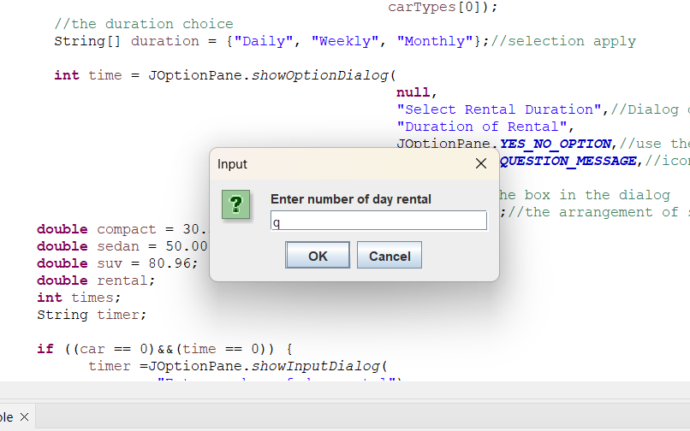

Sedan Weekly

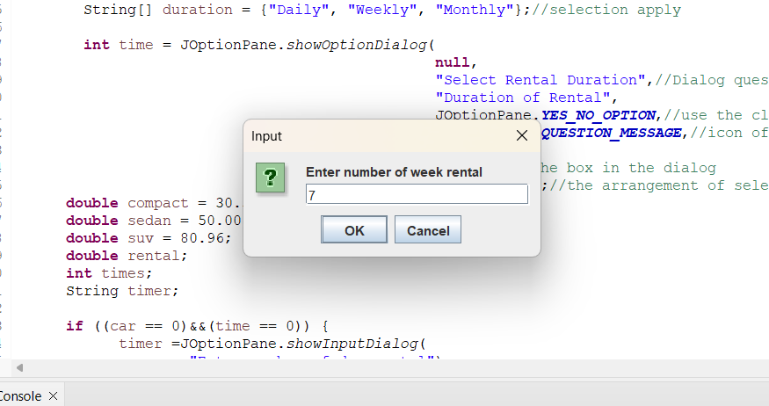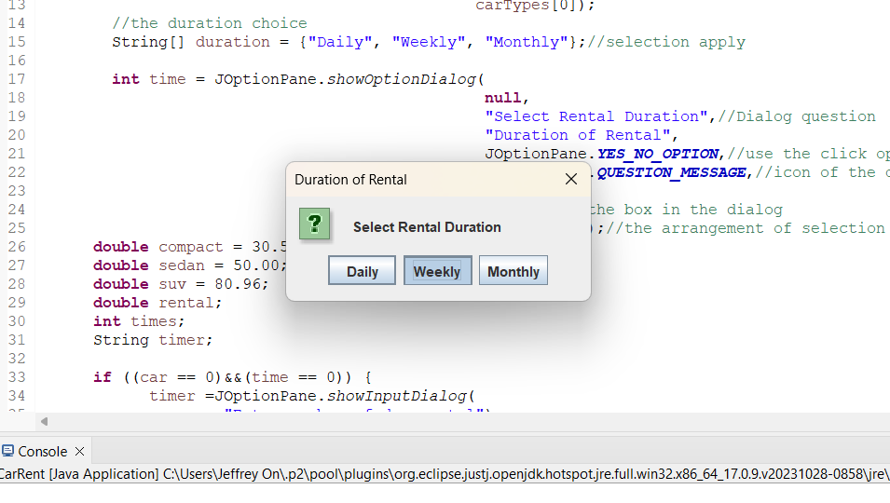(Positive Number)

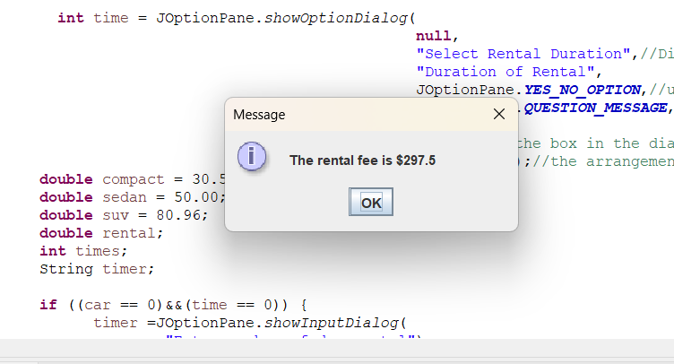

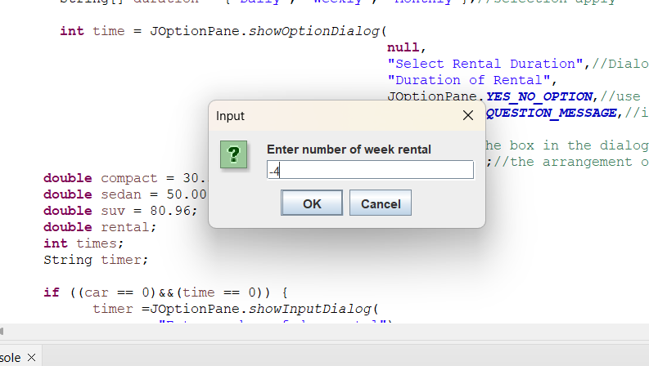(Negative Number)

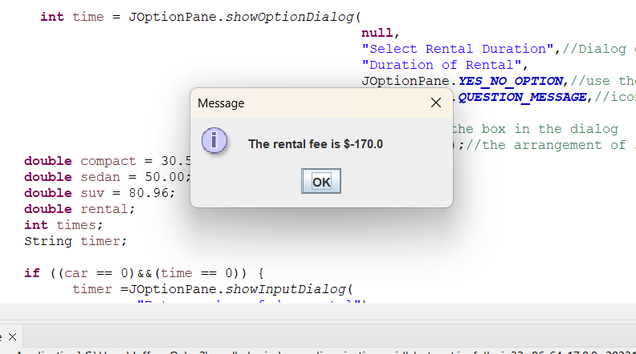

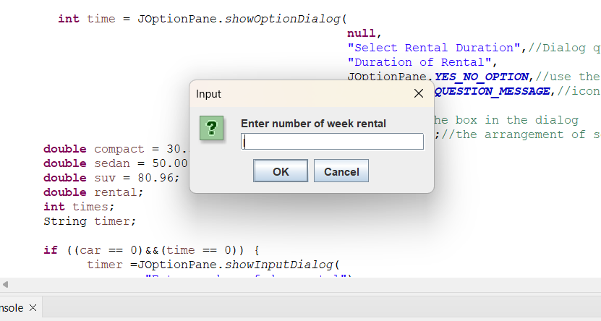(Default)

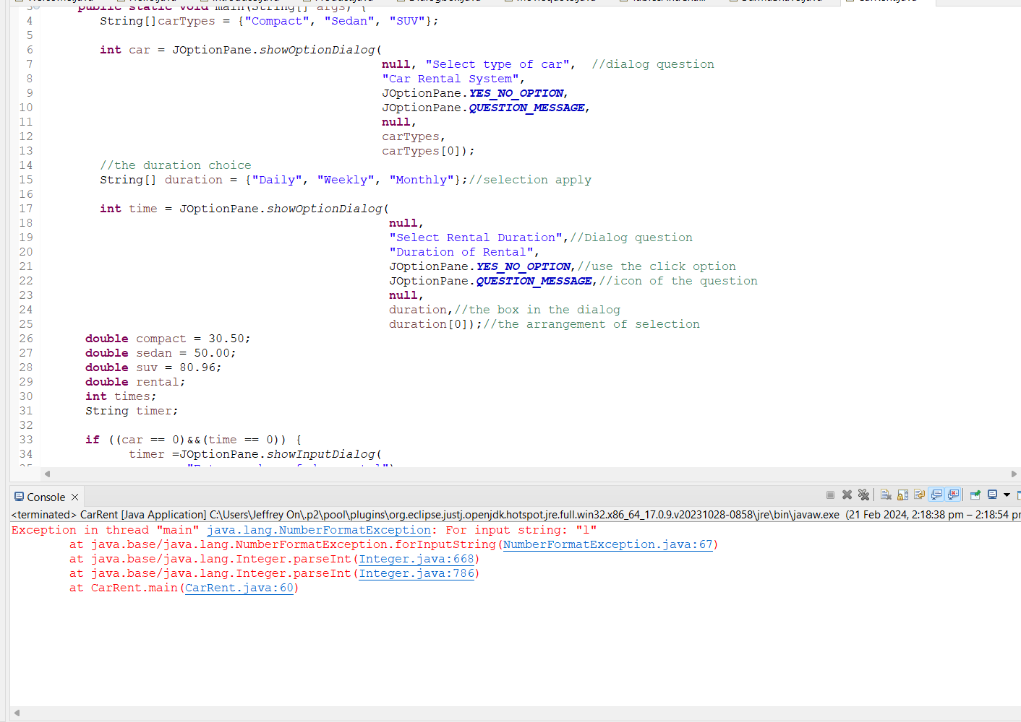

Sedan Monthly

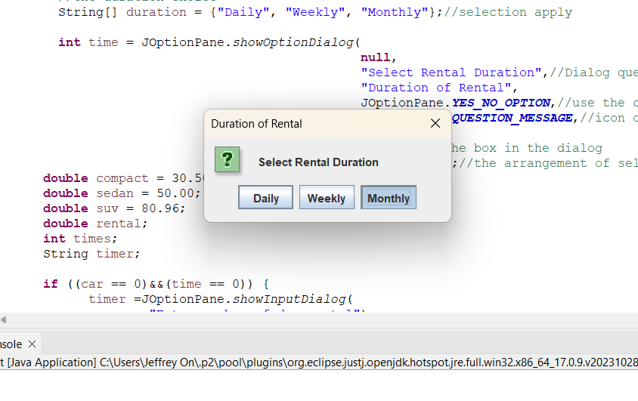(Positive Number)

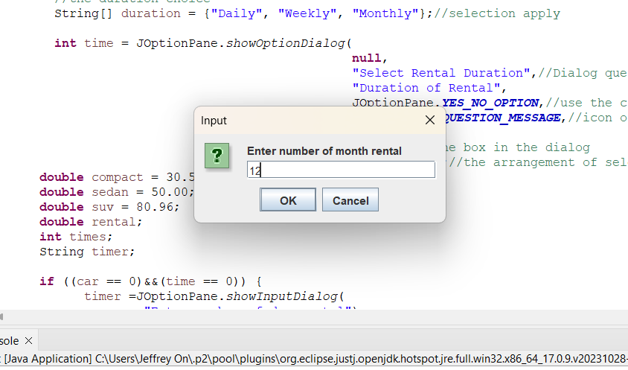

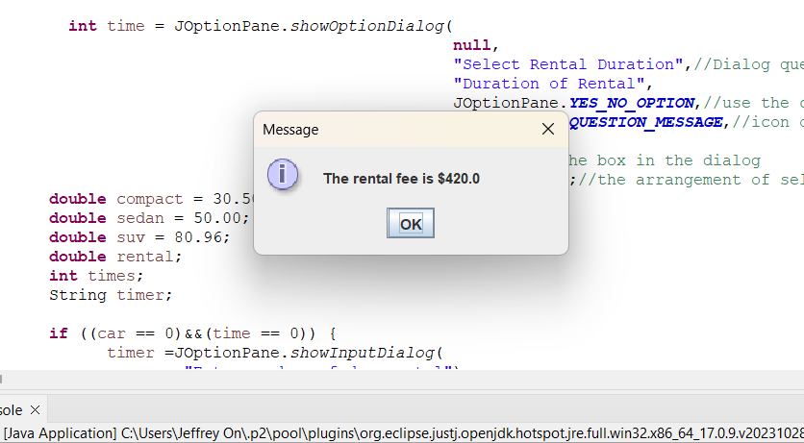

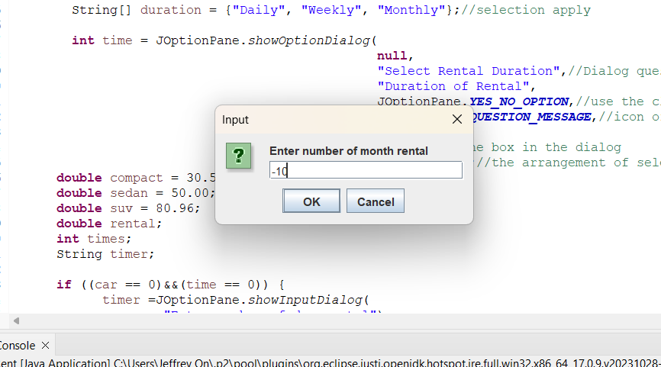(Negative Number)

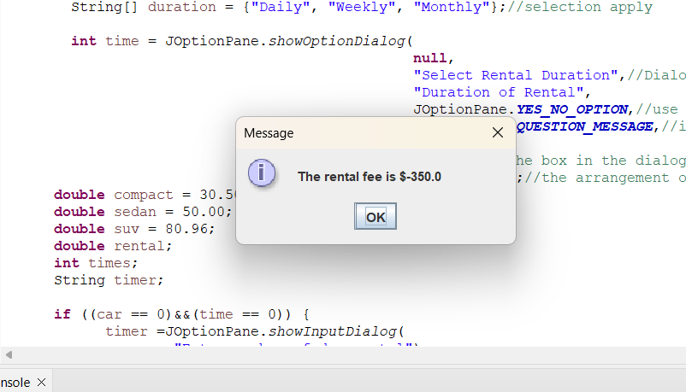

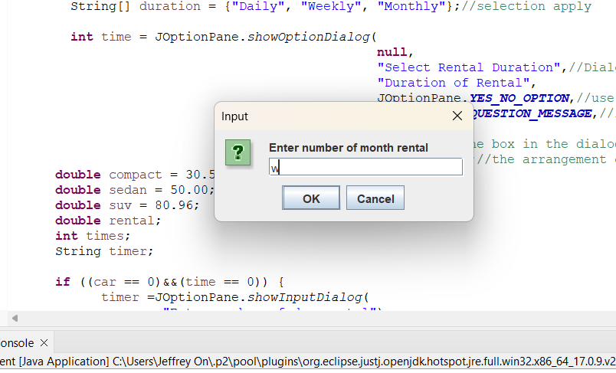(Default)

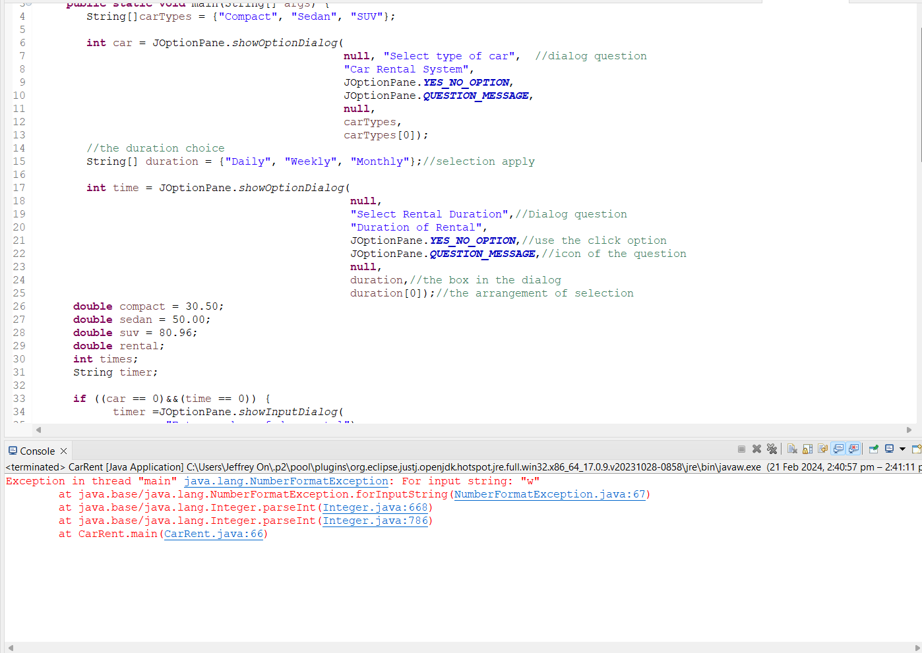

SUV Daily

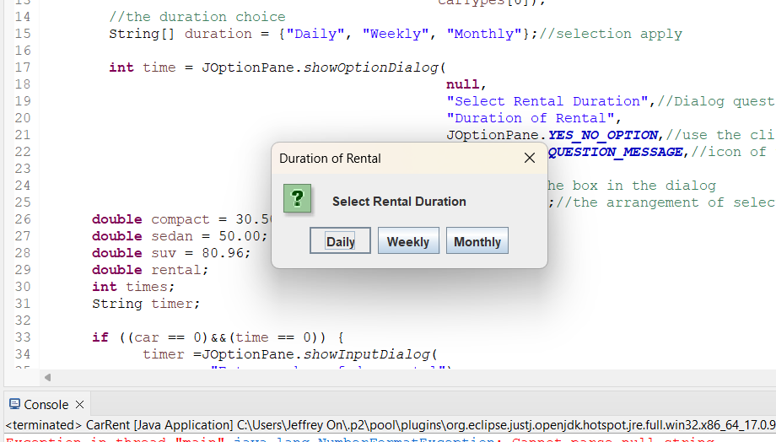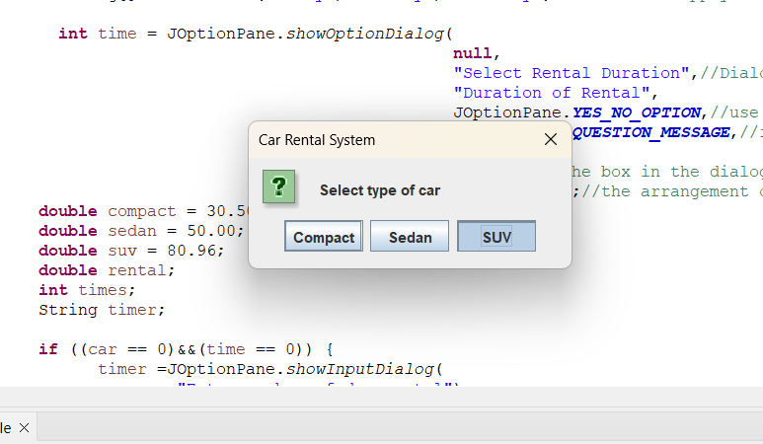(Positive Number)

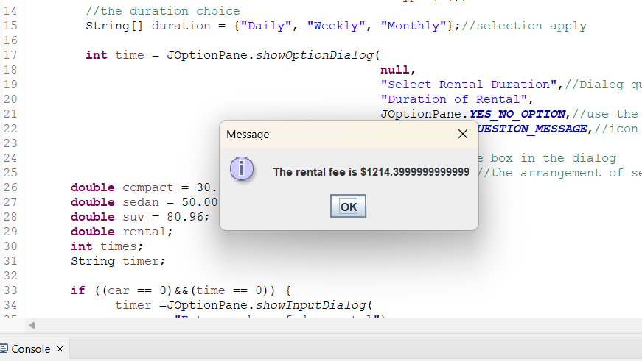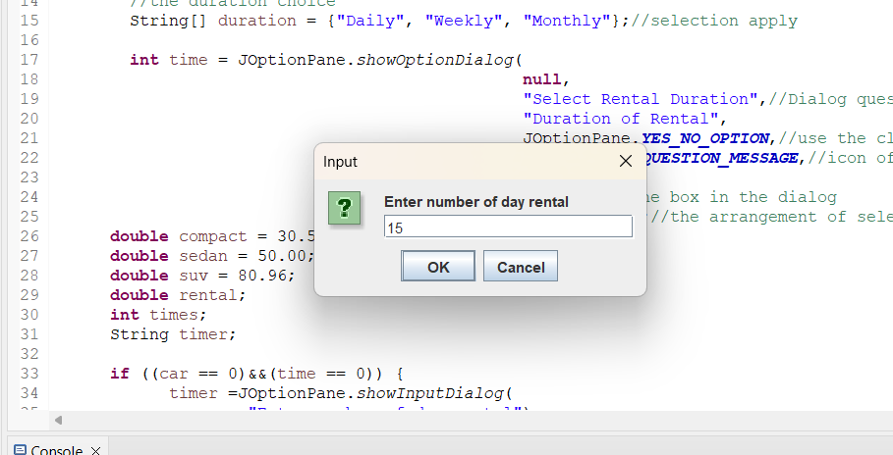

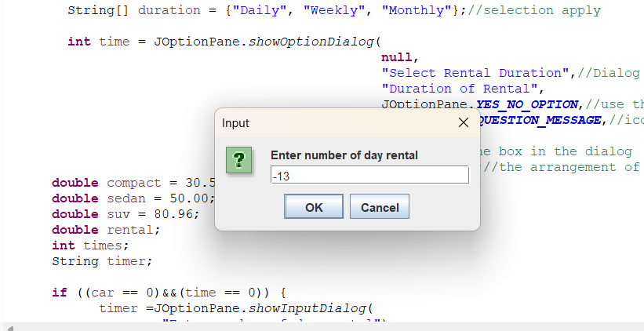(Negative Number)

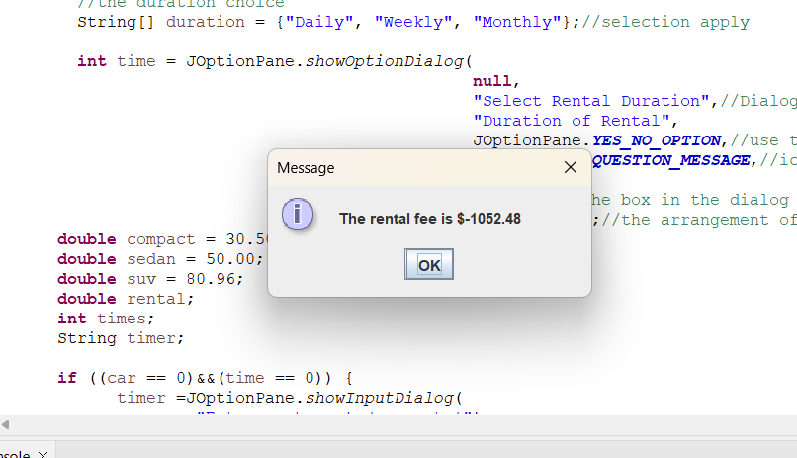

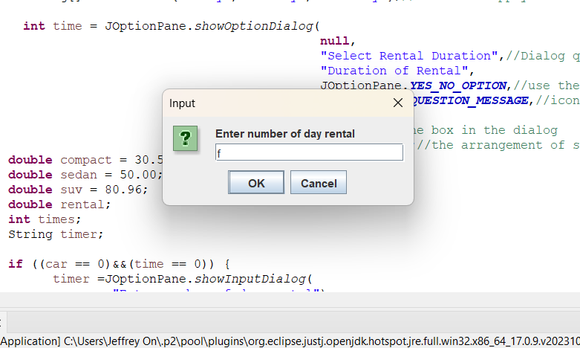(Default)

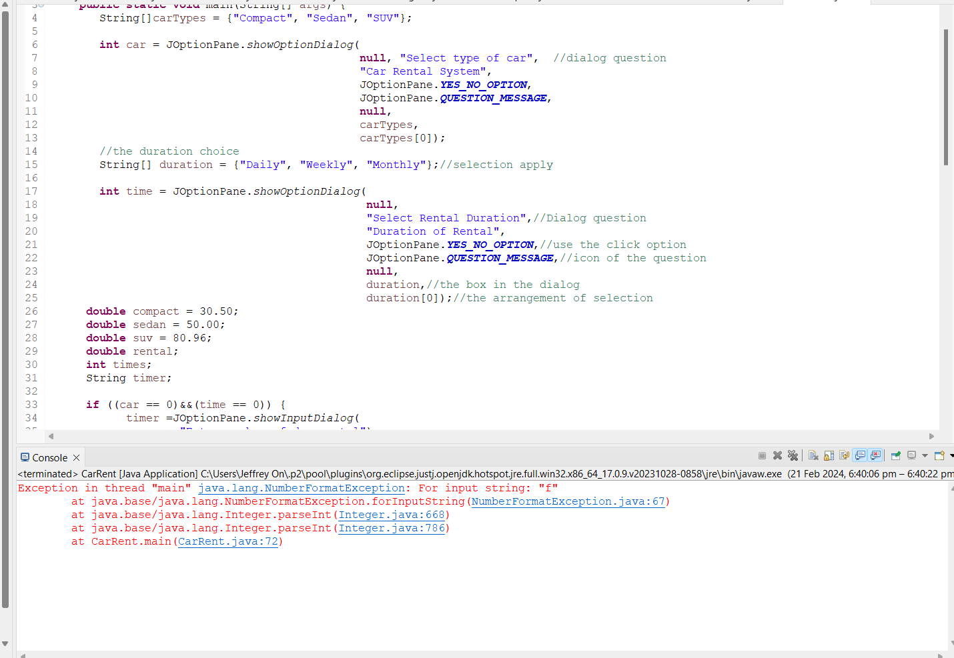

SUV Weekly

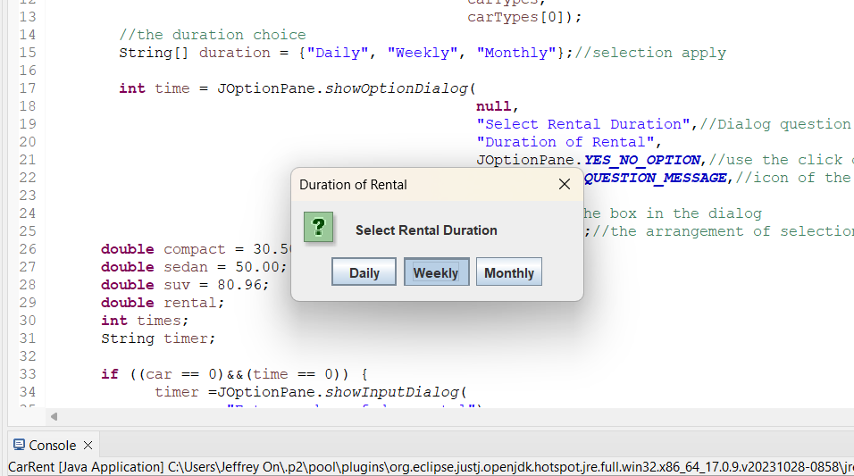(Positive Number)

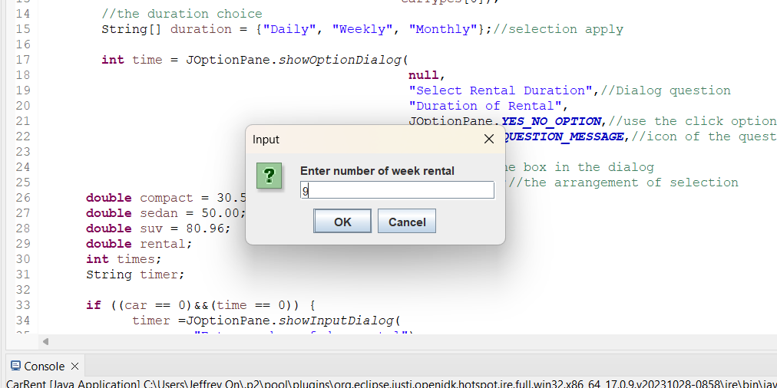

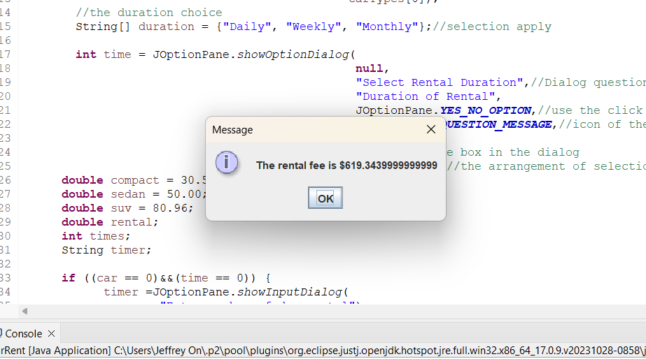

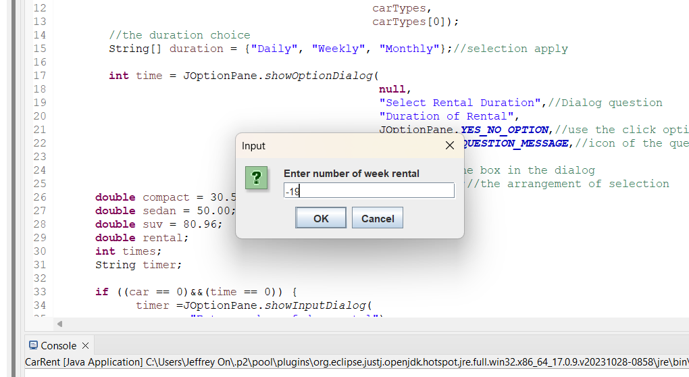(Negative Number)

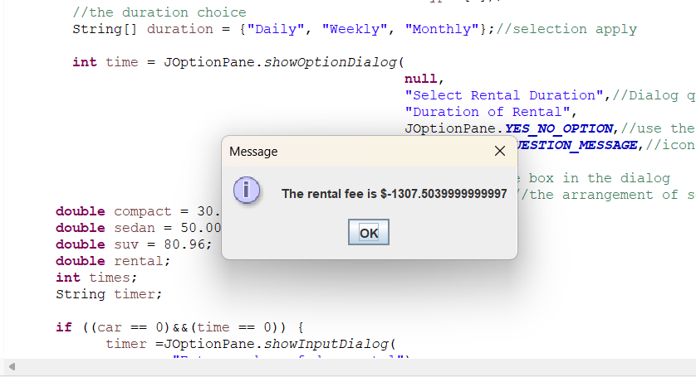

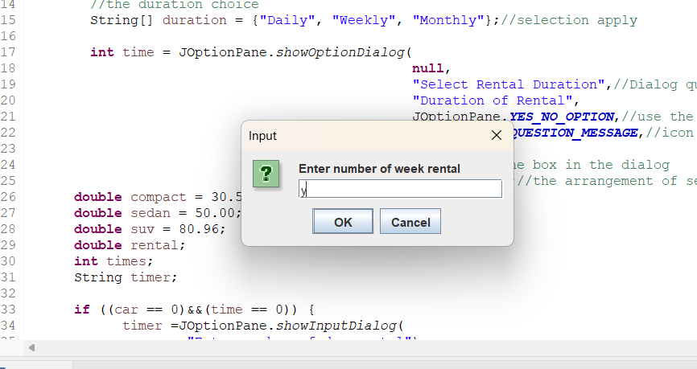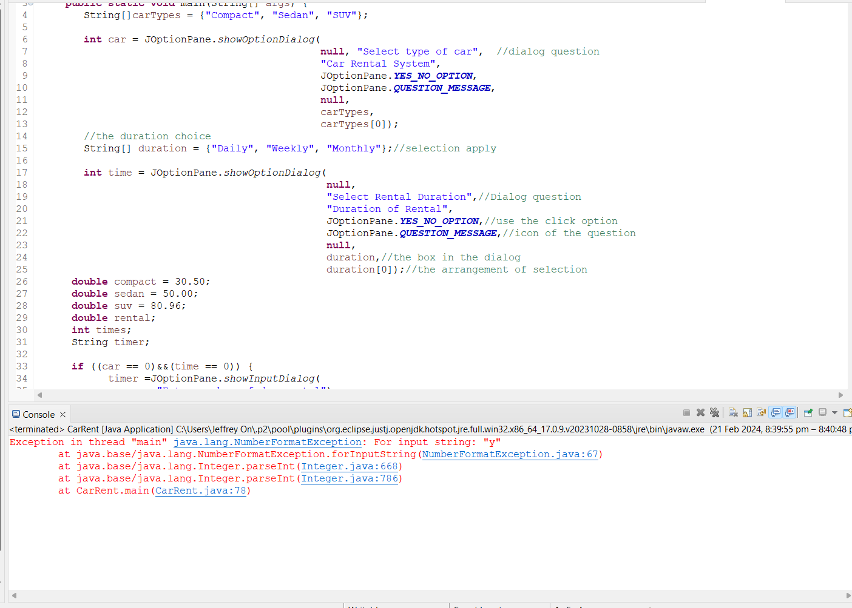(Default)

Sedan Monthly

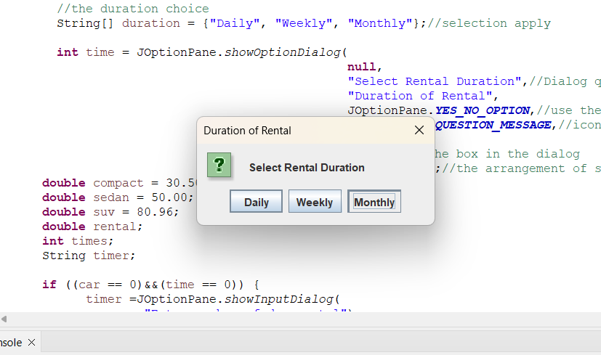(Positive Number)

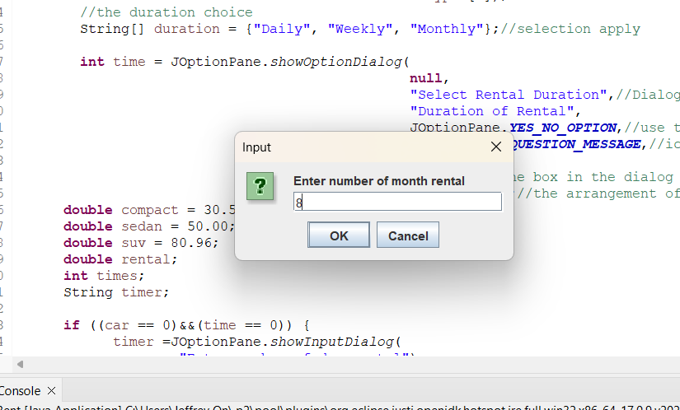

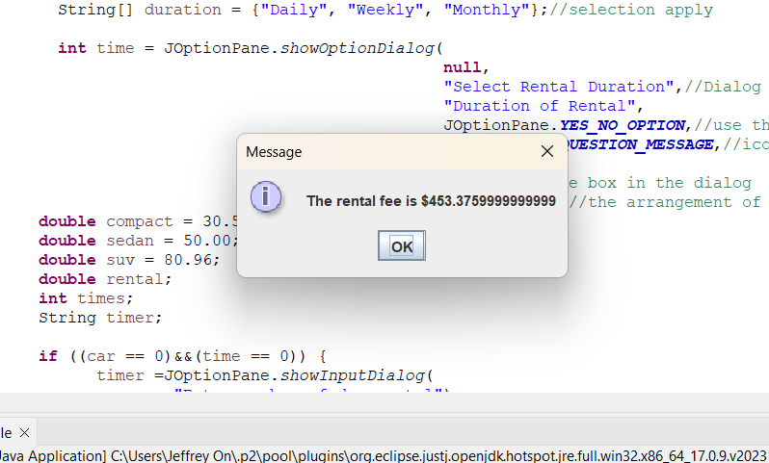

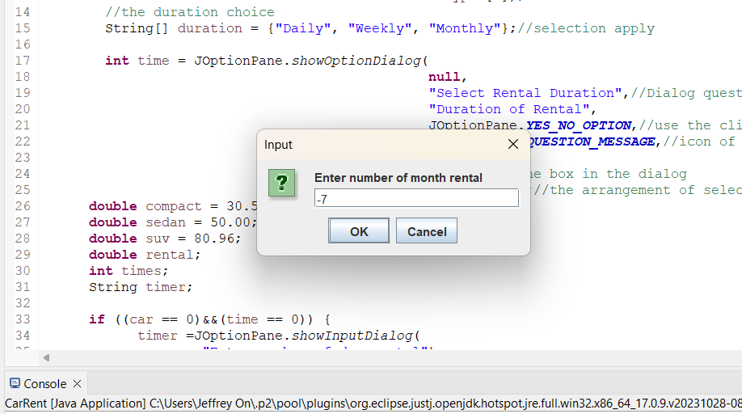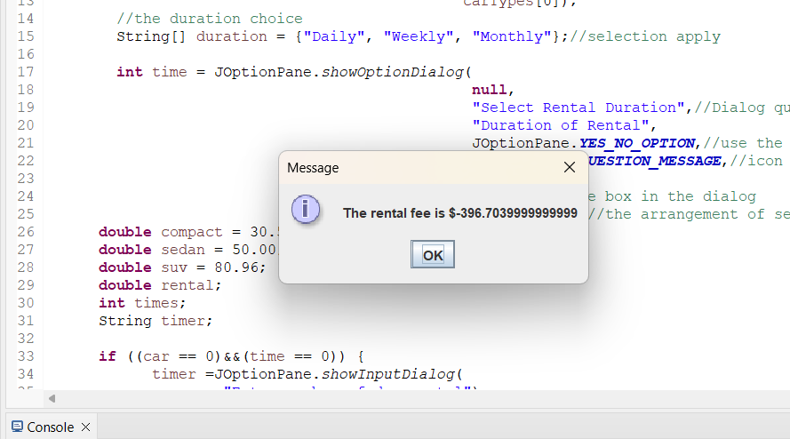(Negative Number)

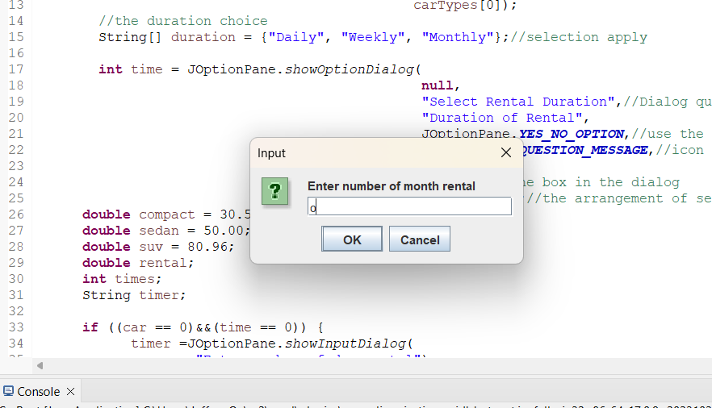(Default)

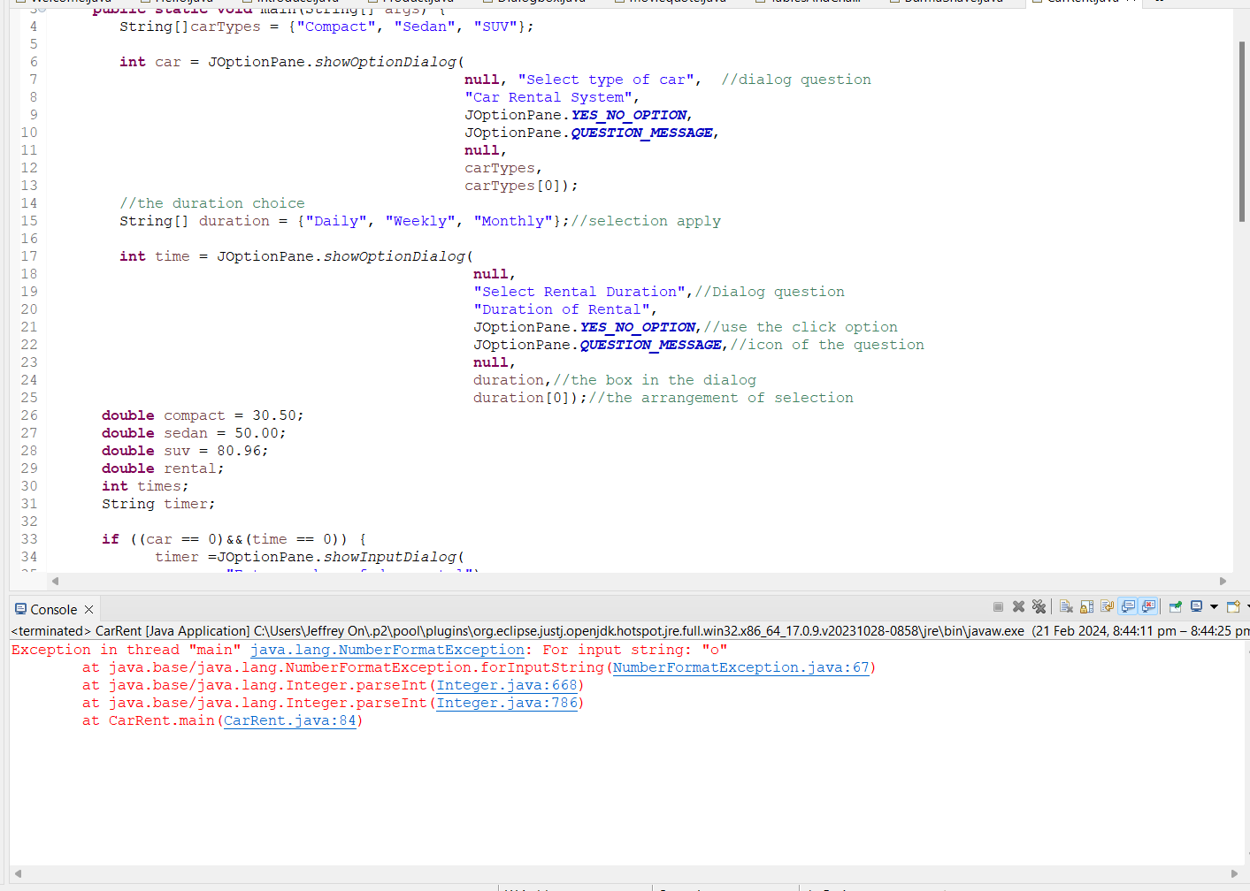

Task:

Write a Java program to create aa calculator with a menu. The program should allow users to perform basic arithmetic operations such as addition, subtraction, multiplication, division, and remainder. Your program should display a menu for options allowing the user to choose which operation to perform and prompt the user to select an option. Based on the choice, the user will be prompted to enter the two numbers for operation. Note that the program should incorporate *Switch* and *If…. Else* to prevent user from arithmetic error like dividing by 0.

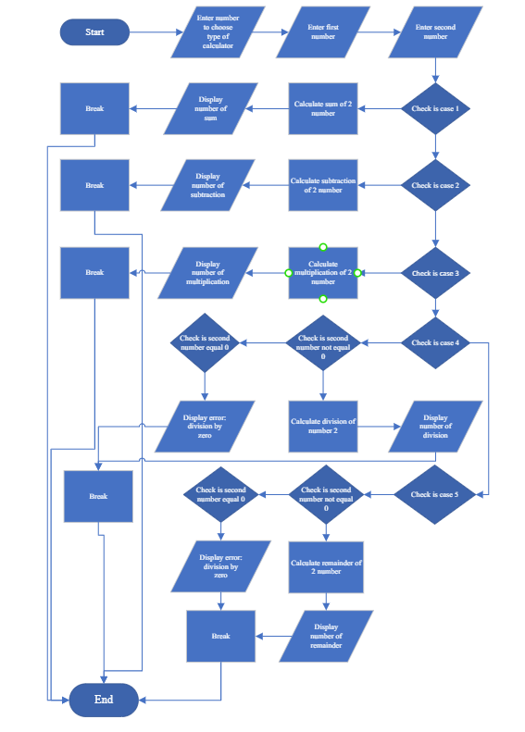

**import** java.util.Scanner;

**public** **class** Calculator {

**public** **static** **void** main(String[] args) {

**double** num, num1, num2;

Scanner number = **new** Scanner(System.***in***);

System.***out***.print(

"1. Addition\n"+

"2. Subtraction\n"+

"3. Multiplication\n"+

"4. Division\n"+

"5. Remainder\n"+

"Enter your choice >>");

**int** selection = number.nextInt();

System.***out***.print("Enter first number");

num1 = number.nextDouble();

System.***out***.print("Enter second number");

num2 = number.nextDouble();

**switch** (selection) {

**case** 1:

num = num1 + num2;

System.***out***.println("Number of sum "+num);

**break**;

**case** 2:

num = num1 - num2;

System.***out***.println("Number of subtraction "+num);

**break**;

**case** 3:

num = num1 * num2;

System.***out***.println("Number of multiplication "+num);

**break**;

**case** 4:

**if** (num2 != 0) {

num = num1 / num2;

System.***out***.println("Number of division "+num);

}

**else**

System.***out***.println("Error: Division by zero!");

**break**;

**case** 5:

**if** (num2 != 0) {

num = num1 % num2;

System.***out***.println("Number of remainder "+num);

}

**else**

System.***out***.println("Error: Division by zero!");

**break**;

}

}

}

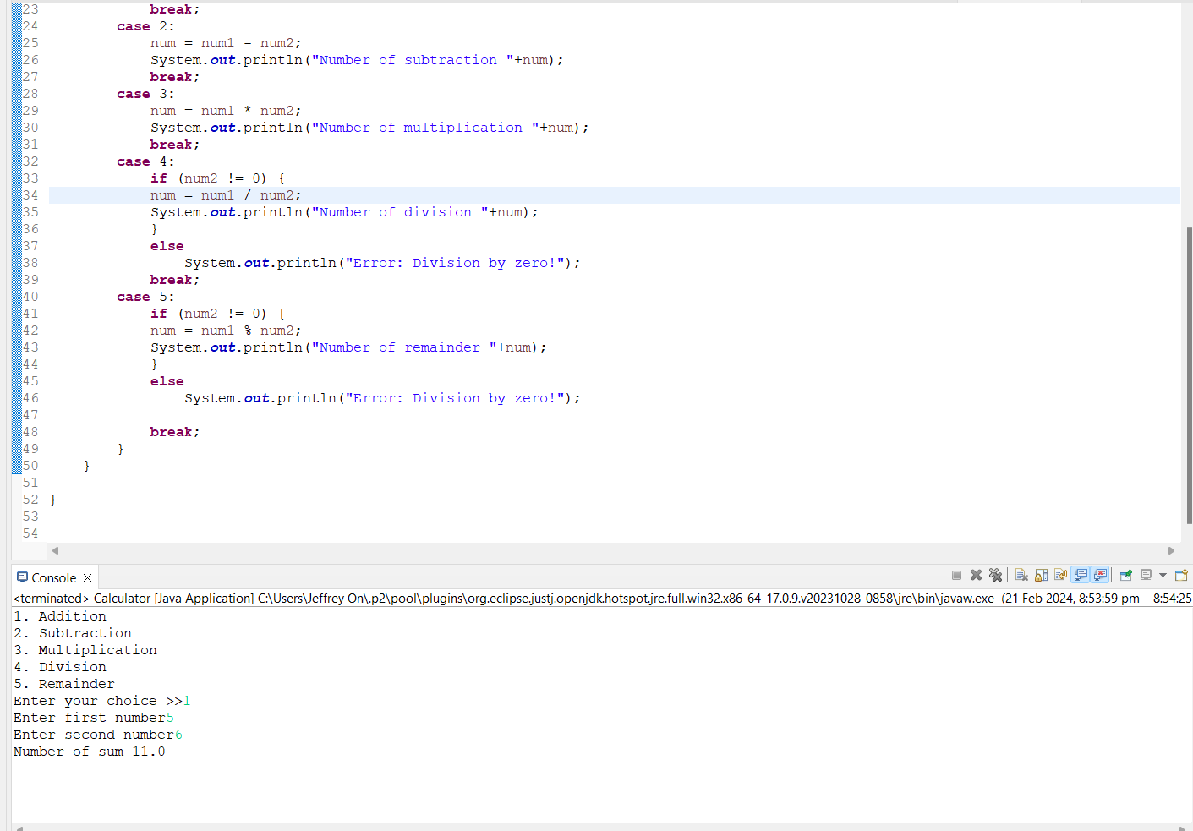(Calculator Positive Number)

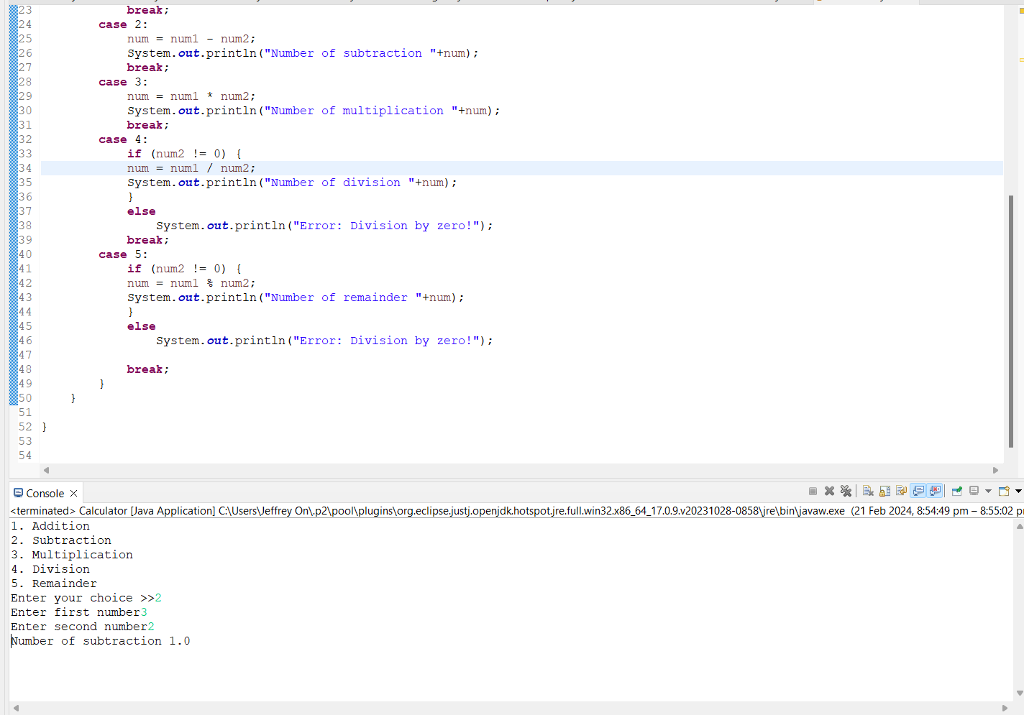

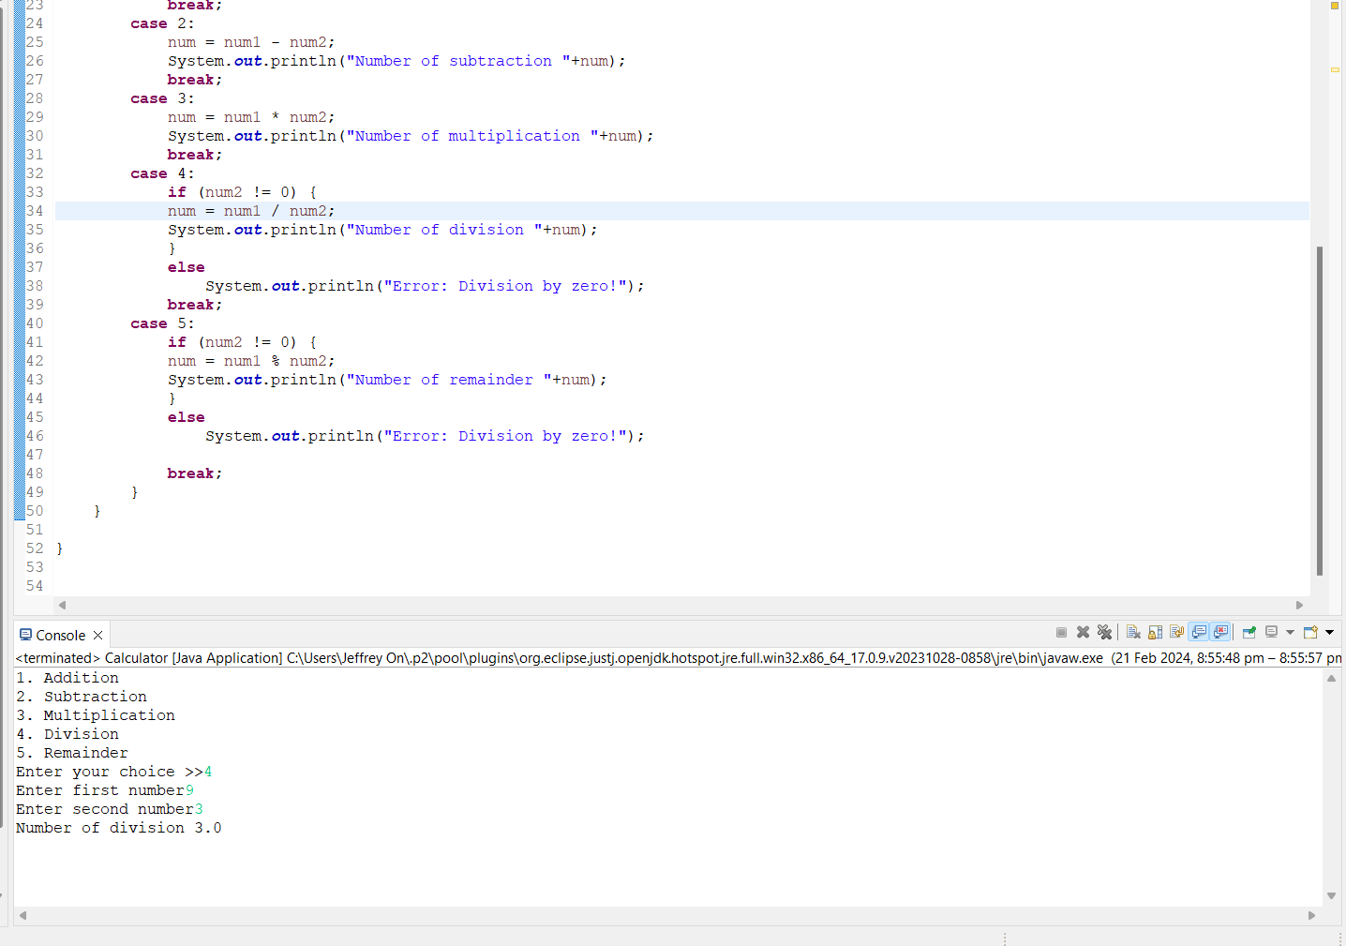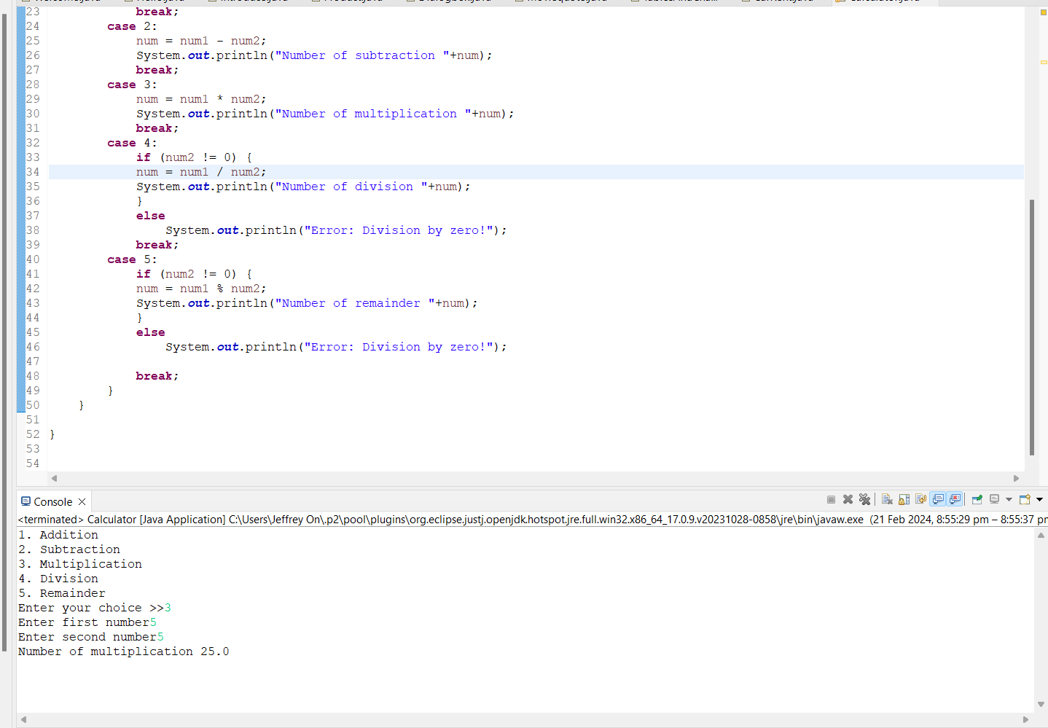

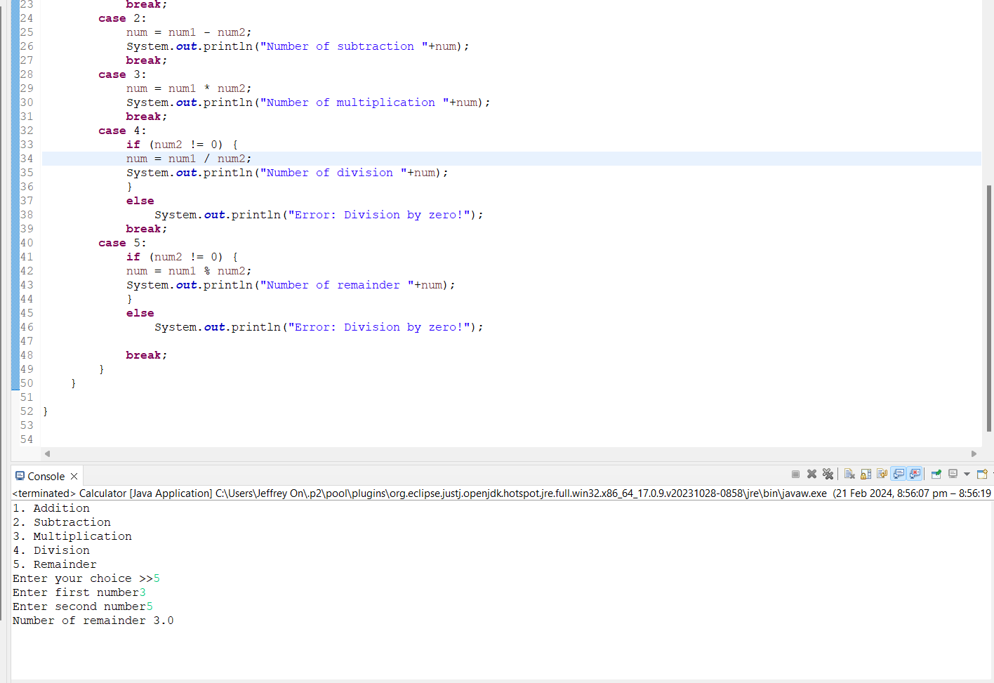

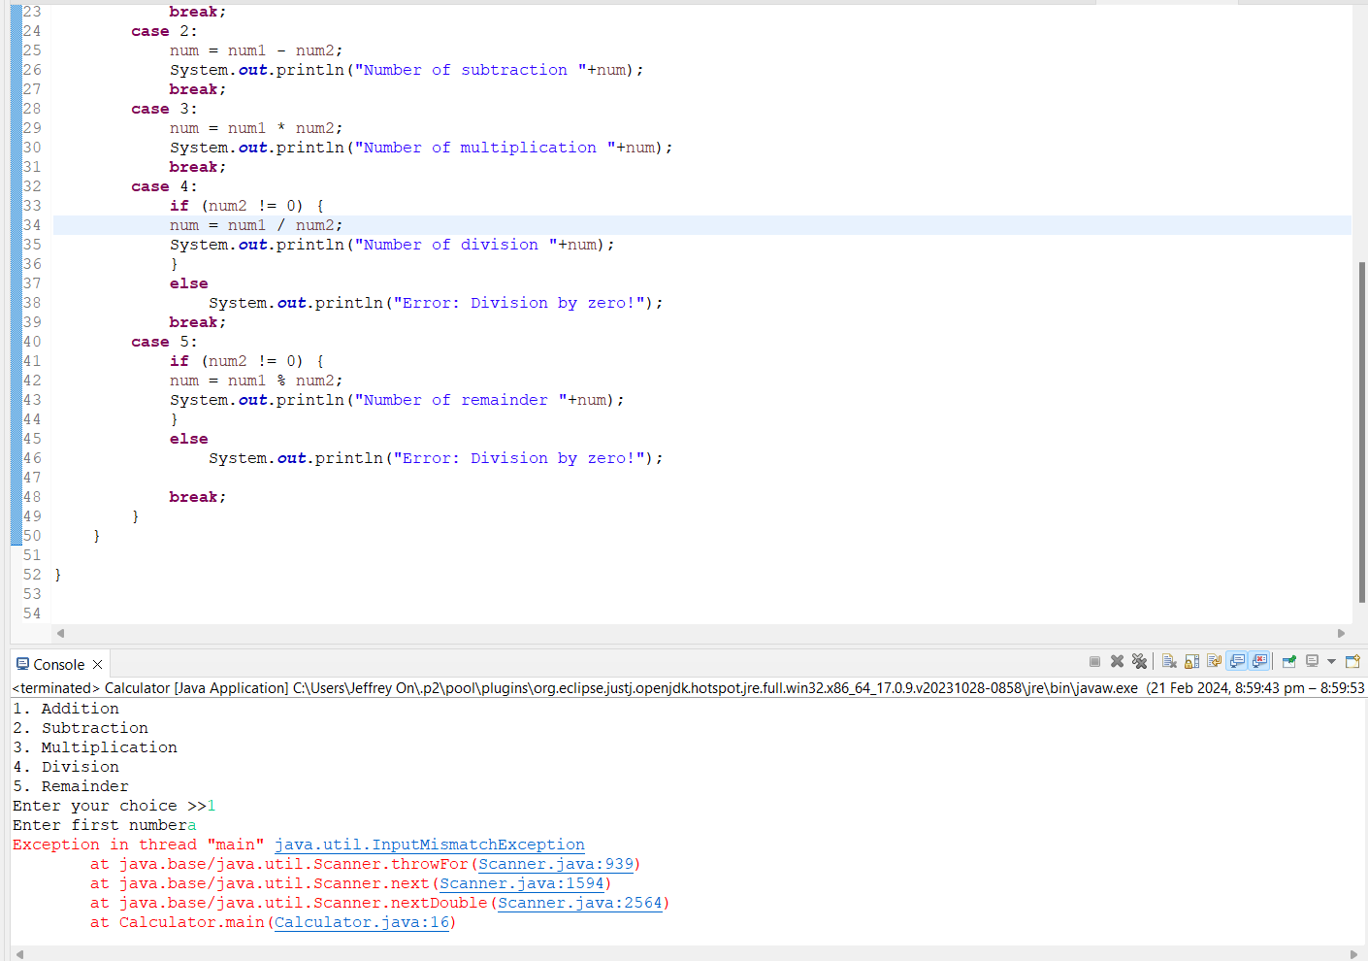(Default)